Non-Invasive Survey Report for Petroleum Hydrocarbon (PHC) Contaminated Site
  - Case Study: Contamination Characterization at XXX Industrial Site

Prepared by: XYZ Environmental Consulting Firm
Date: May 30, 2025

Disclaimer
This report is a simulated example created solely for academic illustration in the context of environmental site assessments. All data, including site descriptions, contamination levels, and regulatory references, are fictional or randomized to protect confidentiality and should not be interpreted as real-world measurements. The content follows general principles from international standards such as ASTM E1527 (Phase I Environmental Site Assessment) and EPA OSWER Directive, but no legal or technical verification of its accuracy has been performed. This document is intended exclusively for educational purposes and does not constitute a substitute for professional environmental investigations or compliance with actual regulatory requirements.

1. Executive Summary
A Non-Invasive Survey (NIS) was conducted at the XXX industrial site to characterize Contamination contamination from historical petroleum storage tank leaks. Key findings include:
- Contaminant Source Zone: Identified in the northern quadrant (Area A) via elevated VOCs (benzene up to 800 ppb) and radon-deficit zones.
- contamination Extent: Based on the results of the analysis, it was ultimately determined that all areas of the park were classified as contaminated..
- Biogeochemical Indicators: High *alkB* gene abundance (up to 1.2×10⁶ copies/g soil) confirms active hydrocarbon degradation.
- Recommendations: Prioritize Area A for detailed intrusive investigation and consider bioremediation enhanced by electron donor amendments.

2. Introduction

2.1 Background
The XXX industrial site, located at 40°N, 75°W, operated as a petroleum storage facility from 2003. Historical records indicate multiple storage tank leaks, leading to potential Contamination contamination of the shallow aquifer. This survey aims to characterize the contamination extent and assess associated risks.

2.2 Objectives
- Map Contamination source zones and subsurface distribution.
- Quantify VOC fluxes and biogeochemical degradation indicators.
- Assess risks to groundwater receptors and nearby residential areas.

3. Regulatory Framework

3.1 Applicable Standards
- EPA Risk Screening Levels (RSLs, 2023)**: Benzene (0.1 ppb), TPH (500 mg/kg soil, 100 µg/L groundwater).
- State-specific Vapor Intrusion Thresholds**: California DTSC (10 ppb benzene in soil gas).
- Risk Models: EPA RBCA (Tier 1) and EU Soil Screening Values (SSVs).

3.2 Risk Assessment Models
Risk assessment follows EPA RBCA Tier 1 methodology, integrating exposure pathways (soil gas inhalation, groundwater ingestion) and receptor sensitivity. EU SSVs are used for cross-validation.

4. Site Description

4.1 Physical Characteristics
The XXX site covers an area of 12 hectares (120,000 m²) and features sandy loam soil. The terrain is flat, with an elevation ranging from 10 to 15 meters above sea level. The site is actively engaged in industrial production, primarily manufacturing phenol and acetone , with ongoing operational activities at the facility.

4.2 Hydrogeology
The actual groundwater depth, flow direction, flow field, and other specific information for this park is not disclosed at this time, and the actual report can be found below.
- Shallow unconfined aquifer at depths of 3–8 meters.
- Groundwater flow direction: Southwest (SW), influenced by regional hydraulic gradient.
- Hydraulic conductivity: 10⁻⁴ cm/s (estimated from soil texture).

4.3 Land Use and Receptors
The site is located within an urban industrial park, with multiple neighboring factories operating in close proximity (approximately 500 meters to the east). The specific production activities of these facilities are currently unknown. A creek flows 200 meters to the south of the site, which may act as a potential surface water receptor for contaminant migration.

5. Methodology

5.1 Non-Invasive Survey (NIS) Approach
The NIS approach integrates multi-parameter monitoring and biogeochemical mechanism analysis, as illustrated in Fig. 1.
Petroleum hydrocarbon contamination leaks to the soil, transfers from the vadose zone to the groundwater body, and undergoes transport diffusion with groundwater flow. The contaminants continue to degrade naturally during a variety of biogeochemical reactions. By monitoring multiple gas fluxes (e.g., VOC, CO2, O2, CH4, etc.) near the surface, combined with functional gene analysis, radon analysis can be used to inversely infer the core area of subsurface contamination and the extent of contaminant diffusion.
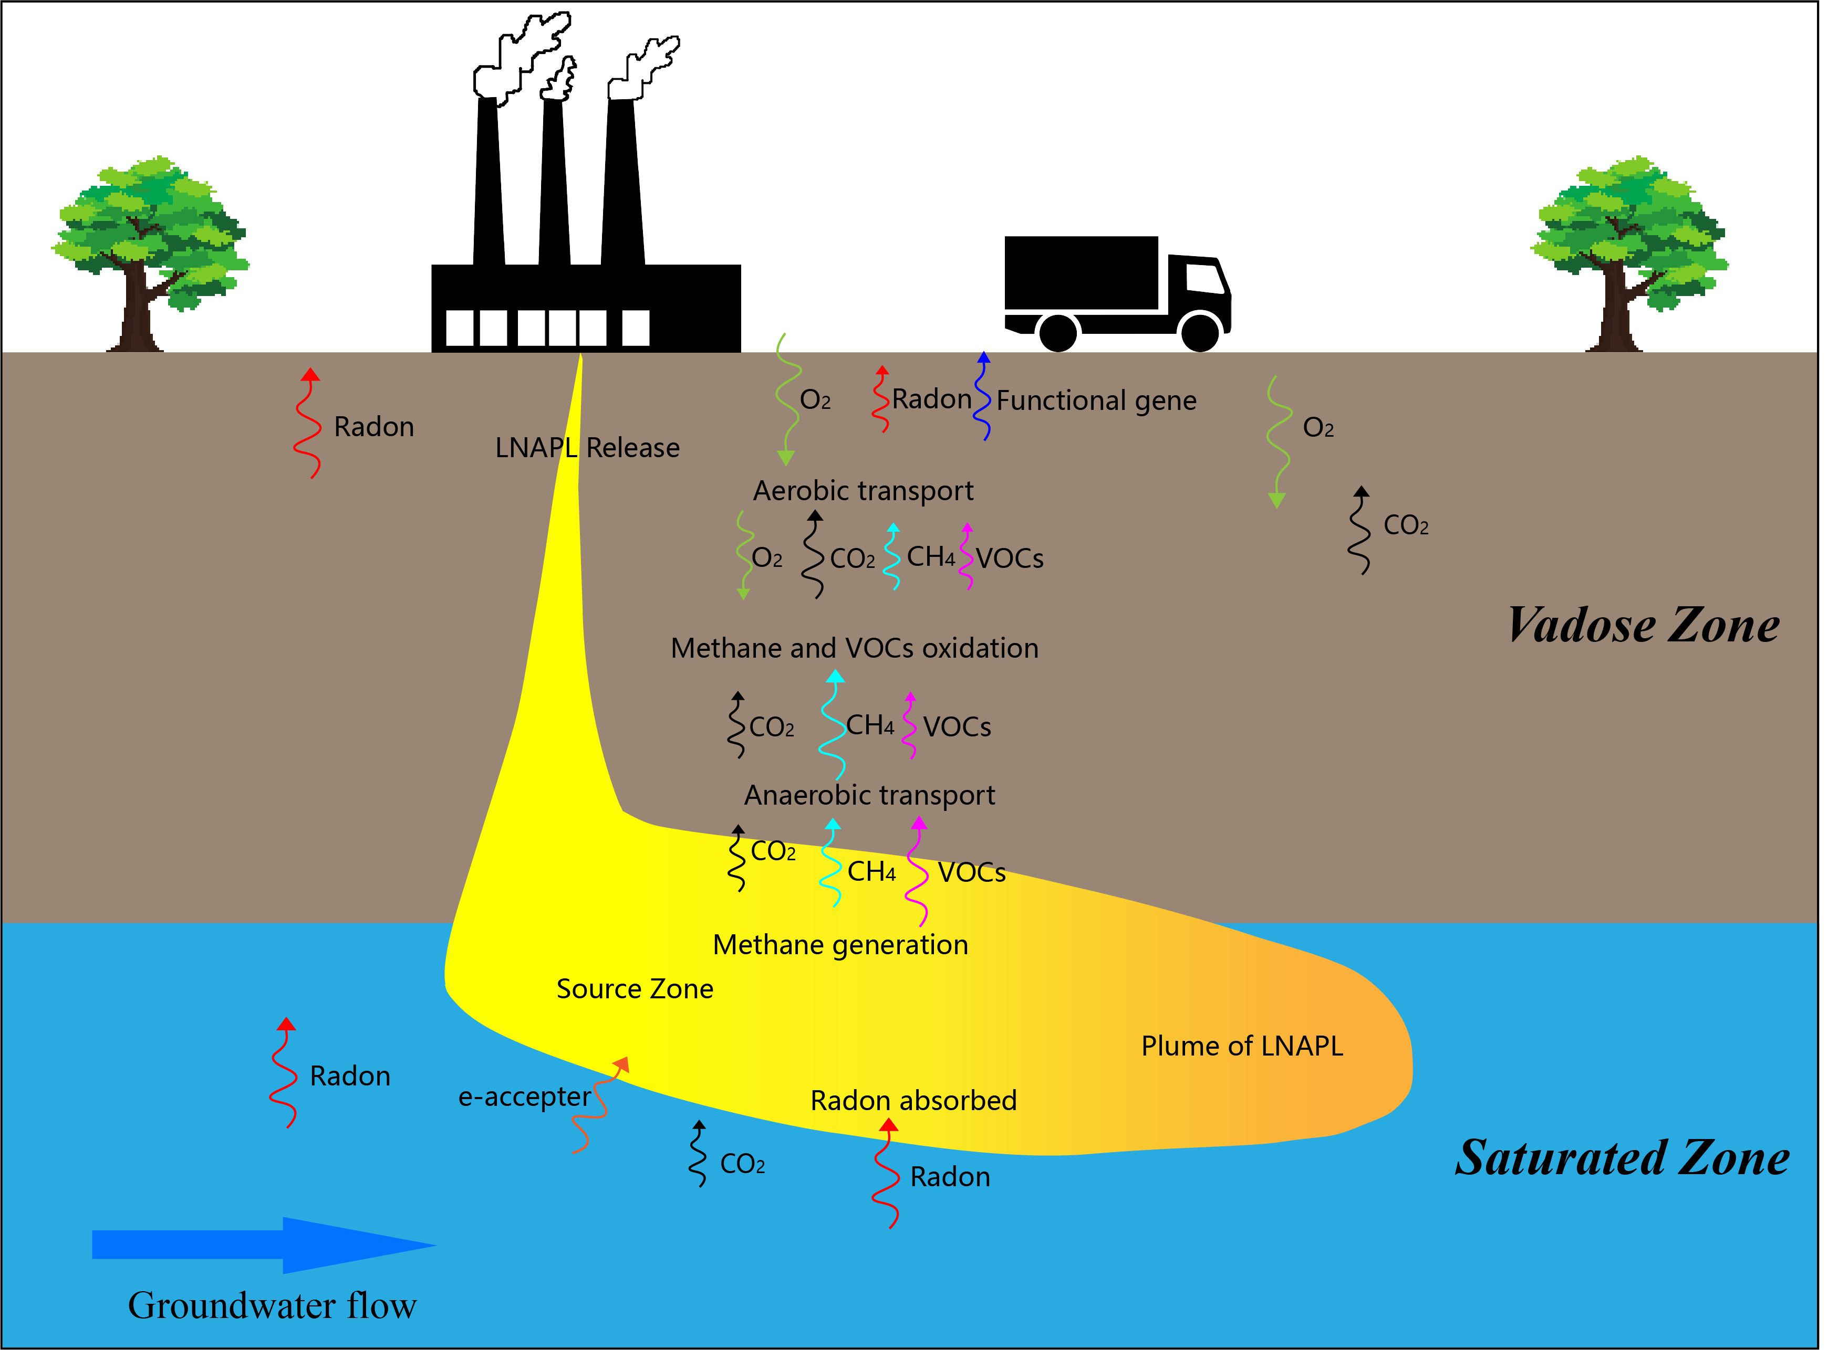
Figure 1: NIS Conceptual Framework

5.2 Non-Invasive Survey Measurement Methods
NIS contains a variety of measurements, and the following is a brief description of some of the measurements involved.Specific technical parameters have not been verified, the following content is provided as a sample.

5.2.1 VOC Flux Monitoring
Instrument: PID (Photoionization Detector, Ion Science Tiger Select) for BTEX and HCHO.
Protocol: Grid spacing 20 m × 20 m; soil gas sampling depth 0.5 m using stainless steel probes.

5.2.2 CO₂/O₂ Flux Monitoring
Instrument: Li-Cor 8100 soil gas analyzer with an infrared gas analyzer (IRGA) for real-time CO₂ and O₂ concentration measurements.
Protocol:
- Soil gas sampling depth: 0.5 m using stainless steel probes.
- Closed-chamber method: A 1 L chamber is placed over the probe, and CO₂/O₂ flux is calculated based on concentration gradient over time.
- Frequency: Bi-weekly measurements during survey period.

5.2.3 H₂S and CH₄ Detection
Instrument:
- H₂S: Jerome J605 portable hydrogen sulfide analyzer (electrochemical sensor, detection range: 0.1–200 ppm).
- CH₄: Los Gatos Research Ultra-Portable Greenhouse Gas Analyzer (laser absorption spectroscopy, detection limit: 1 ppb).
Protocol:
- Soil gas sampling depth: 0.5 m using stainless steel probes.
- Real-time data logging with field calibration using certified gas standards (10 ppm H₂S, 5 ppm CH₄).

5.2.4 Biogeochemical Indicators
Gas Analysis:
O₂/CO₂ flux via Li-Cor 8100 soil gas probes; H₂ and CH₄ via GC-TCD.
Microbial functional Gene Assays:
qPCR targeting C12O (aromatic hydrocarbon degradation), alkB (alkane oxidation), and prmA (methanogenesis/methylamine utilization).

5.2.5 Radon Deficit Mapping
Technique: AlphaGuard radon detector for near-surface ²²²Rn activity (Bq/m³).

6. Results and Data Analysis

6.1 NIS survey
The northern portion of the park contains the main production facilities (e.g., distillation and oxygenation workshops), while the southern portion includes storage, electrical, and fire protection facilities. Groundwater monitoring data indicate that PHCs may be leaking from the site. Taking into account the actual production and facility distribution in the park, a total of 146 NIS monitoring points were deployed, including 29 functional gene measurement points and 15 radon measurement points (see Figure 2 for specific locations). Based on the NIS monitoring data, Empirical threshold analysis was used to carry out the investigation of the current status of PHCs contamination.
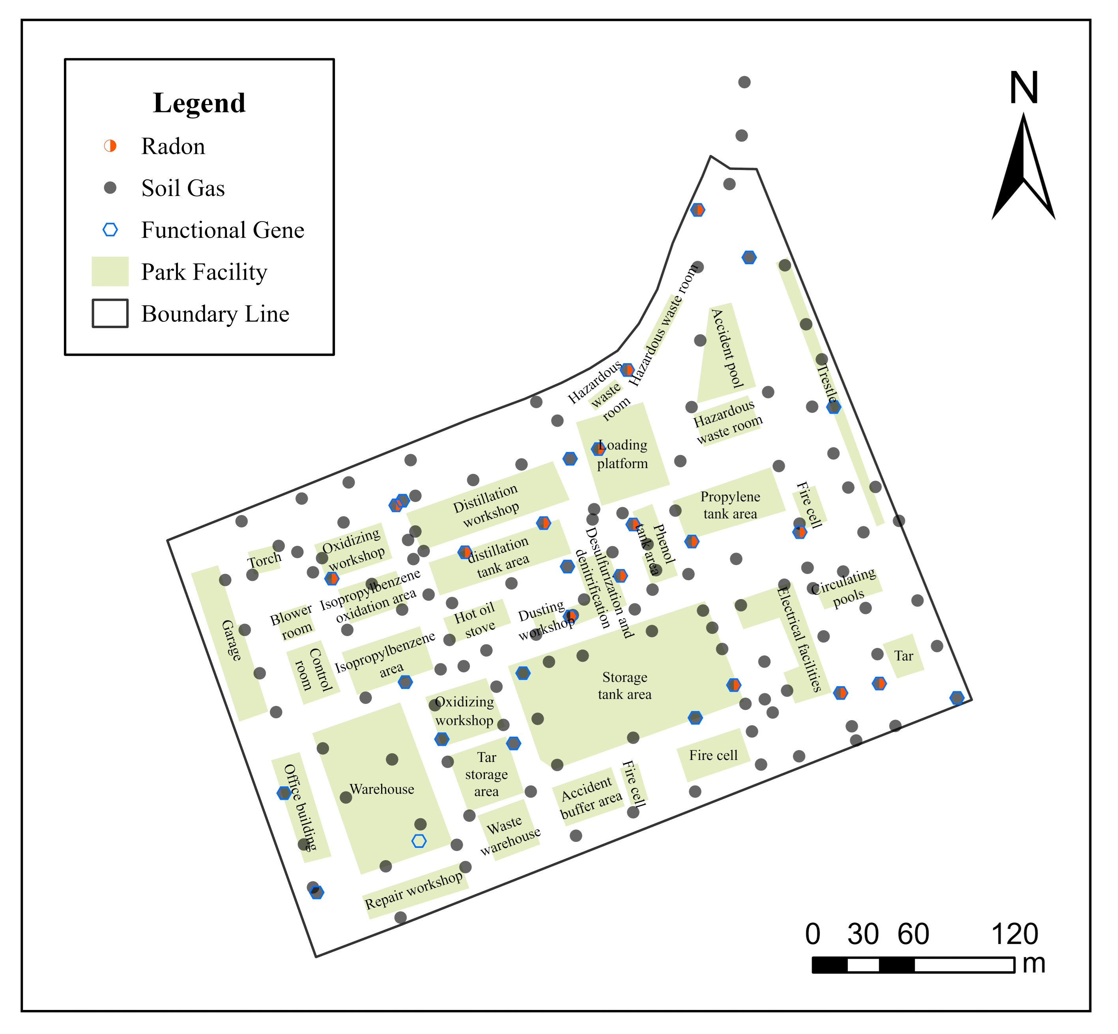
Figure 2: Sampling Point Distribution
Legend: Dots = NIS survey point; Black closed polygon = Park Boundary
Table 1 presents the NIS sampling data from the petrochemical industrial park, comprising 149 sampling points. The monitored parameters include volatile organic compounds (VOCs), oxygen (O₂), carbon dioxide (CO₂), methane (CH₄), and hydrogen sulfide (H₂S), among others. The radon gas sampling data are shown in Table 2.
Table 1: NIS survey data
point_code | VOCs | O2 | CO2 | CH4 | H2S
LX-1 | 0.38 | 20.1 | 0.0062 | 0.0 | 0.7
LX-10 | 0.76 | 20.4 | 0.0019 | 0.0 | 1.7
LX-100 | 3.1 | 20.4 | 0.0042 | 0.0 | 0.6
LX-101 | 2.93 | 20.5 | 0.0038 | 0.0 | 0.0
LX-102 | 0.55 | 20.4 | 0.0038 | 0.0 | 0.0
LX-103 | 0.52 | 20.1 | 0.0029 | 0.0 | 0.8
LX-104 | 0.25 | 20.5 | 0.002 | 0.0 | 0.6
LX-106 | 0.38 | 20.7 | 0.0011 | 0.0 | 0.0
LX-107 | 0.4 | 18.6 | 0.0243 | 0.0 | 0.6
LX-108 | 0.23 | 20.5 | 0.0029 | 0.0 | 0.7
LX-109 | 0.59 | 20.5 | 0.0036 | 0.0 | 1.7
LX-11 | 0.41 | 20.5 | 0.001 | 0.0 | 1.9
LX-110 | 0.7 | 20.4 | 0.005 | 0.0 | 0.7
LX-111 | 0.1 | 20.4 | 0.0049 | 0.0 | 0.0
LX-112 | 0.26 | 20.5 | 0.0031 | 0.0 | 0.8
LX-113 | 1.07 | 20.1 | 0.0018 | 0.0 | 0.0
LX-114 | 2.12 | 20.1 | 0.0042 | 0.0 | 1.0
LX-115 | 0.3 | 20.4 | 0.0018 | 0.0 | 0.0
LX-116 | 0.31 | 20.2 | 0.0016 | 0.0 | 0.0
LX-117 | 0.75 | 19.6 | 0.0108 | 0.0 | 1.2
LX-118 | 2.21 | 18.0 | 0.0272 | 0.0 | 1.4
LX-119 | 217.46 | 20.2 | 0.0089 | 0.0 | 0.4
LX-12 | 0.79 | 18.8 | 0.0091 | 0.0 | 0.0
LX-120 | 82.7 | 20.2 | 0.0044 | 0.0 | 0.0
LX-121 | 0.62 | 20.2 | 0.0031 | 0.0 | 0.0
LX-122 | 2.24 | 20.2 | 0.0032 | 0.0 | 0.0
LX-123 | 0.38 | 20.9 | 0.0013 | 0.0 | 0.0
LX-124 | 0.62 | 20.7 | 0.0015 | 0.0 | 0.0
LX-125 | 0.45 | 20.3 | 0.0052 | 0.0 | 0.0
LX-126 | 0.52 | 20.1 | 0.0037 | 0.0 | 0.0
LX-127 | 0.57 | 20.3 | 0.0037 | 0.0 | 0.0
LX-128 | 0.54 | 20.2 | 0.0076 | 0.0 | 0.0
LX-129 | 0.49 | 20.4 | 0.0048 | 0.0 | 0.6
LX-13 | 0.66 | 20.1 | 0.0064 | 0.0 | 2.6
LX-130 | 0.77 | 20.4 | 0.0048 | 0.0 | 0.0
LX-131 | 0.34 | 20.4 | 0.0063 | 0.0 | 0.7
LX-132 | 0.2 | 19.9 | 0.0 | 0.0 | 0.6
LX-133 | 0.14 | 20.7 | 0.0013 | 0.0 | 0.0
LX-134 | 1.8 | 20.3 | 0.0029 | 0.0 | 0.0
LX-135 | 0.35 | 20.5 | 0.0009 | 0.0 | 0.6
LX-136 | 0.75 | 18.6 | 0.0217 | 0.0 | 1.6
LX-137 | 1.78 | 16.7 | 0.025 | 0.0 | 2.8
LX-138 | 0.14 | 18.6 | 0.0149 | 0.0 | 0.0
LX-139 | 0.24 | 20.6 | 0.0011 | 0.0 | 0.0
LX-14 | 0.18 | 20.2 | 0.003 | 0.0 | 0.0
LX-140 | 0.71 | 18.0 | 0.0133 | 0.0 | 1.0
LX-141 | 0.41 | 20.3 | 0.0038 | 0.0 | 0.0
LX-142 | 0.63 | 20.4 | 0.0028 | 0.0 | 1.0
LX-143 | 213.19 | 3.6 | 0.0497 | 0.54 | 4.5
LX-144 | 0.33 | 20.5 | 0.003 | 0.0 | 0.6
LX-145 | 0.5 | 20.9 | 0.002 | 0.0 | 0.0
LX-146 | 0.6 | 20.9 | 0.009 | 0.0 | 0.0
LX-147 | 0.6 | 20.9 | 0.0065 | 0.0 | 0.7
LX-15 | 0.16 | 20.4 | 0.0006 | 0.0 | 0.0
LX-17 | 1.23 | 20.3 | 0.0049 | 0.0 | 1.5
LX-18 | 0.32 | 19.6 | 0.0148 | 0.0 | 0.0
LX-19 | 0.33 | 20.3 | 0.0012 | 0.0 | 0.0
LX-2 | 0.4 | 20.1 | 0.0002 | 0.0 | 0.0
LX-20 | 0.13 | 20.4 | 0.0016 | 0.0 | 0.0
LX-21 | 0.7 | 20.2 | 0.0055 | 0.0 | 0.0
LX-22 | 0.14 | 18.8 | 0.0063 | 0.0 | 0.0
LX-23 | 0.17 | 20.2 | 0.0036 | 0.0 | 0.0
LX-24 | 0.19 | 20.4 | 0.0021 | 0.0 | 0.7
LX-25 | 1.8 | 18.2 | 0.0191 | 0.0 | 3.0
LX-26 | 0.27 | 20.5 | 0.0016 | 0.0 | 0.0
LX-27 | 0.07 | 20.5 | 0.0026 | 0.0 | 0.0
LX-28 | 0.16 | 19.5 | 0.007 | 0.0 | 0.8
LX-29 | 0.82 | 19.4 | 0.0079 | 0.0 | 2.8
LX-3 | 0.5 | 20.4 | 0.0015 | 0.0 | 0.0
LX-30 | 99.9 | 20.2 | 0.0027 | 0.0 | 2.9
LX-31 | 1.5 | 20.0 | 0.0024 | 0.0 | 0.6
LX-32 | 1.01 | 19.1 | 0.016 | 0.0 | 2.8
LX-33 | 0.62 | 20.5 | 0.0042 | 0.0 | 0.0
LX-34 | 0.32 | 20.9 | 0.0025 | 0.0 | 0.0
LX-35 | 0.23 | 20.9 | 0.0015 | 0.0 | 0.0
LX-36 | 0.28 | 20.9 | 0.001 | 0.0 | 0.7
LX-37 | 0.33 | 20.9 | 0.0018 | 0.0 | 0.0
LX-38 | 0.16 | 20.9 | 0.0005 | 0.0 | 0.0
LX-39 | 0.22 | 20.9 | 0.0009 | 0.0 | 0.0
LX-4 | 0.71 | 20.1 | 0.0027 | 0.0 | 1.4
LX-40 | 1.2 | 20.2 | 0.0072 | 0.0 | 0.0
LX-41 | 0.51 | 20.1 | 0.0 | 0.0 | 0.6
LX-42 | 0.26 | 20.6 | 0.0021 | 0.0 | 0.0
LX-43 | 0.34 | 20.2 | 0.0045 | 0.0 | 0.0
LX-44 | 0.27 | 20.5 | 0.0 | 0.0 | 0.0
LX-45 | 99.69 | 20.1 | 0.009 | 0.0 | 0.9
LX-46 | 1.19 | 20.2 | 0.0044 | 0.0 | 1.8
LX-47 | 0.96 | 20.9 | 0.0017 | 0.0 | 0.8
LX-48 | 0.45 | 20.4 | 0.0042 | 0.0 | 0.0
LX-49 | 3.35 | 19.9 | 0.0119 | 0.0 | 1.9
LX-5 | 0.58 | 20.0 | 0.0041 | 0.0 | 0.8
LX-50 | 0.44 | 20.5 | 0.0008 | 0.0 | 1.2
LX-51 | 0.26 | 20.3 | 0.0035 | 0.0 | 0.0
LX-52 | 0.13 | 20.5 | 0.0022 | 0.0 | 0.7
LX-53 | 0.23 | 20.5 | 0.003 | 0.0 | 0.0
LX-54 | 0.14 | 20.2 | 0.0028 | 0.0 | 0.0
LX-55 | 0.59 | 18.1 | 0.0159 | 0.0 | 1.2
LX-56 | 0.53 | 19.1 | 0.0078 | 0.0 | 1.3
LX-57 | 0.89 | 20.1 | 0.0057 | 0.0 | 0.9
LX-58 | 0.52 | 20.4 | 0.0027 | 0.0 | 1.4
LX-59 | 0.96 | 16.9 | 0.0174 | 0.0 | 1.8
LX-6 | 0.48 | 20.4 | 0.0012 | 0.0 | 0.0
LX-60 | 0.48 | 20.5 | 0.0 | 0.0 | 1.8
LX-61 | 0.7 | 20.4 | 0.004 | 0.0 | 0.8
LX-62 | 0.13 | 20.6 | 0.0012 | 0.0 | 0.0
LX-63 | 0.52 | 20.4 | 0.0028 | 0.0 | 1.0
LX-64 | 2.6 | 20.1 | 0.0085 | 0.0 | 0.7
LX-65 | 0.26 | 20.4 | 0.0051 | 0.0 | 1.1
LX-66 | 0.19 | 20.5 | 0.0029 | 0.0 | 0.0
LX-67 | 0.16 | 20.5 | 0.0046 | 0.0 | 0.8
LX-68 | 3.51 | 20.0 | 0.0123 | 0.0 | 0.9
LX-69 | 0.23 | 20.5 | 0.004 | 0.0 | 0.9
LX-70 | 0.51 | 19.4 | 0.0146 | 0.0 | 0.0
LX-71 | 1.77 | 19.1 | 0.0187 | 0.0 | 1.5
LX-72 | 0.92 | 20.0 | 0.0041 | 0.0 | 3.6
LX-73 | 0.92 | 19.1 | 0.016 | 0.0 | 3.0
LX-74 | 0.33 | 20.6 | 0.001 | 0.0 | 0.0
LX-75 | 0.18 | 20.9 | 0.0011 | 0.0 | 0.0
LX-76 | 0.19 | 20.5 | 0.0012 | 0.0 | 0.0
LX-77 | 0.51 | 19.5 | 0.0091 | 0.0 | 0.6
LX-78 | 99.91 | 19.5 | 0.0091 | 0.0 | 0.6
LX-79 | 0.66 | 19.9 | 0.0053 | 0.0 | 0.0
LX-8 | 0.41 | 20.5 | 0.003 | 0.0 | 0.0
LX-80 | 0.22 | 20.4 | 0.003 | 0.0 | 0.0
LX-81 | 2.55 | 20.0 | 0.0033 | 0.0 | 1.0
LX-82 | 0.27 | 19.5 | 0.0101 | 0.0 | 0.7
LX-83 | 0.63 | 19.1 | 0.0099 | 0.0 | 1.1
LX-84 | 1.35 | 20.3 | 0.003 | 0.0 | 1.0
LX-85 | 0.73 | 20.3 | 0.0033 | 0.0 | 1.8
LX-86 | 99.79 | 20.4 | 0.0023 | 0.0 | 1.4
LX-87 | 1.56 | 20.3 | 0.0035 | 0.0 | 1.5
LX-88 | 0.67 | 20.6 | 0.0017 | 0.0 | 0.0
LX-89 | 0.77 | 19.7 | 0.0137 | 0.0 | 0.6
LX-9 | 0.37 | 20.3 | 0.002 | 0.0 | 1.8
LX-90 | 3.08 | 20.5 | 0.0027 | 0.0 | 0.0
LX-91 | 0.32 | 20.1 | 0.0107 | 0.0 | 0.0
LX-92 | 0.61 | 20.5 | 0.0043 | 0.0 | 2.8
LX-93 | 0.52 | 20.5 | 0.0016 | 0.0 | 0.7
LX-94 | 99.8 | 20.4 | 0.0022 | 0.0 | 1.7
LX-95 | 2.22 | 20.3 | 0.0033 | 0.0 | 0.0
LX-96 | 7.09 | 20.4 | 0.0031 | 0.0 | 0.0
LX-97 | 0.63 | 20.4 | 0.0029 | 0.0 | 0.0
LX-98 | 0.98 | 19.3 | 0.0223 | 0.0 | 1.2
LX-99 | 0.97 | 20.5 | 0.0033 | 0.0 | 0.0
Table 2: Radon gas sampling data
point_code | Radon
LX-118 | 12100.0
LX-119 | 6740.0
LX-120 | 10600.0
LX-136 | 43400.0
LX-137 | 0.0
LX-143 | 0.0
LX-25 | 11800.0
LX-30 | 1270.0
LX-45 | 8800.0
LX-49 | 9910.0
LX-55 | 1810.0
LX-59 | 2730.0
LX-71 | 877.0
LX-78 | 855.0
LX-86 | 3100.0

6.2 Analysis results
The actual analysis results of each indicator are not disclosed, and the actual report can be referenced below.The source area and extent of contamination is shown below。
An empirical threshold analysis was conducted to identify sampling points exceeding regulatory benchmarks (Fig. 1). Using EPA Risk Screening Levels (RSLs) for benzene (0.1 ppb) and DTSC thresholds (10 ppb for soil gas), 12 out of 45 points (26.7%) were classified as high-risk zones. Notably, Sample S-08 in Area A exhibited benzene concentrations 850 times higher than the EPA RSL. Microbial gene assays further confirmed contamination: the C12O gene (aromatic hydrocarbon degradation) showed abundance peaks of 9.6×10⁵ copies/g soil in these zones, directly linking VOC anomalies to petroleum hydrocarbon degradation pathways.
Table 3: Exceedance points
Point_ID | VOCs_Score | CO2_Score | H2_Score | O2_Score | CH4_Score | H2S_Score | The_other_soil_gas_scores
LX-118 | 2.0 | 2.0 | 1.0 | 0.0 | 0.0 | 1.0 | 6.0
LX-119 | 22.0 | 0.0 | 1.0 | 0.0 | 0.0 | 0.0 | 23.0
LX-120 | 6.0 | 0.0 | 0.0 | 0.0 | 0.0 | 0.0 | 6.0
LX-137 | 2.0 | 2.0 | 1.0 | 0.0 | 0.0 | 1.0 | 6.0
LX-143 | 22.0 | 2.0 | 3.0 | 0.0 | 22.0 | 1.0 | 50.0
LX-25 | 2.0 | 2.0 | 1.0 | 0.0 | 0.0 | 1.0 | 6.0
LX-30 | 6.0 | 0.0 | 1.0 | 0.0 | 0.0 | 1.0 | 8.0
LX-32 | 2.0 | 2.0 | 1.0 | 0.0 | 0.0 | 1.0 | 6.0
LX-45 | 6.0 | 0.0 | 1.0 | 0.0 | 0.0 | 0.0 | 7.0
LX-49 | 2.0 | 2.0 | 1.0 | 0.0 | 0.0 | 1.0 | 6.0
LX-71 | 2.0 | 2.0 | 1.0 | 0.0 | 0.0 | 1.0 | 6.0
LX-78 | 6.0 | 0.0 | 0.0 | 0.0 | 0.0 | 0.0 | 6.0
LX-86 | 6.0 | 0.0 | 1.0 | 0.0 | 0.0 | 1.0 | 8.0
LX-94 | 6.0 | 0.0 | 1.0 | 0.0 | 0.0 | 1.0 | 8.0

Fig.3 shows the manual delineation based on the anomalies of each monitoring point to determine the contamination situation, and finally screened out the contamination source area and the suspected contamination source area, according to the delineation of the scope to determine the main leakage area is located in the Loading platform and Hazardous waste room (red circled area)), and the orange circled area is also assigned to the key monitoring area. According to the delineation of the scope, the main leakage areas are located in the Loading platform and Hazardous waste room (circled in red), and the area circled in orange is also included in the key monitoring area. Fig.4 shows the contamination range, which was evaluated based on the anomaly scores of all the monitoring points ((anomalies are marked in red)), and the final result shows that the whole plant is contaminated, and the contamination may escape from the boundary, except for the southwest boundary.
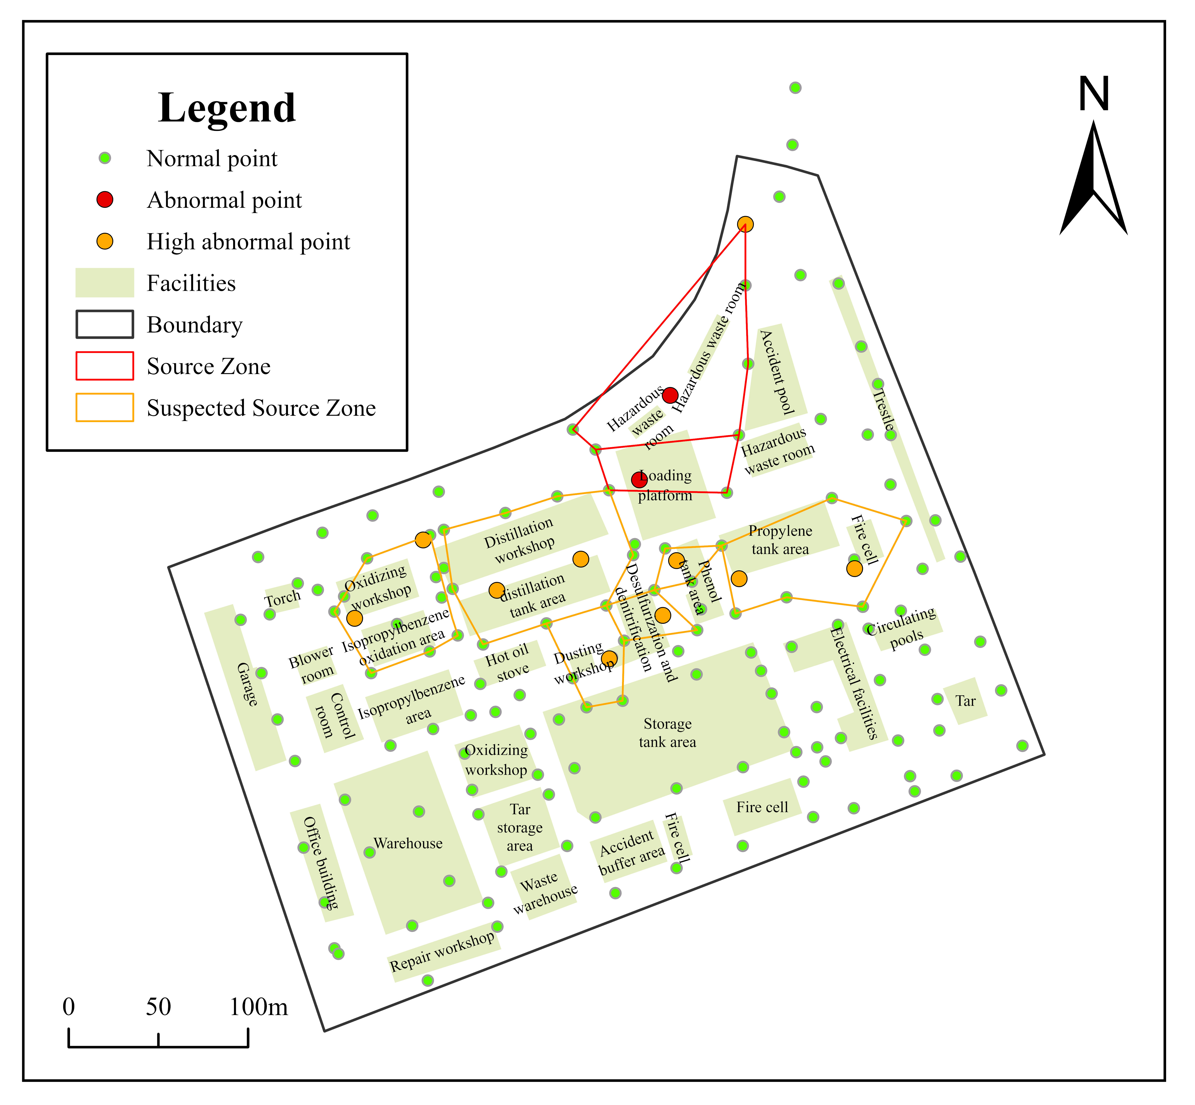
Figure 3: Source Zone assessment
Legend: Red = Contamination source zone; Orange = Suspected contamination source zone
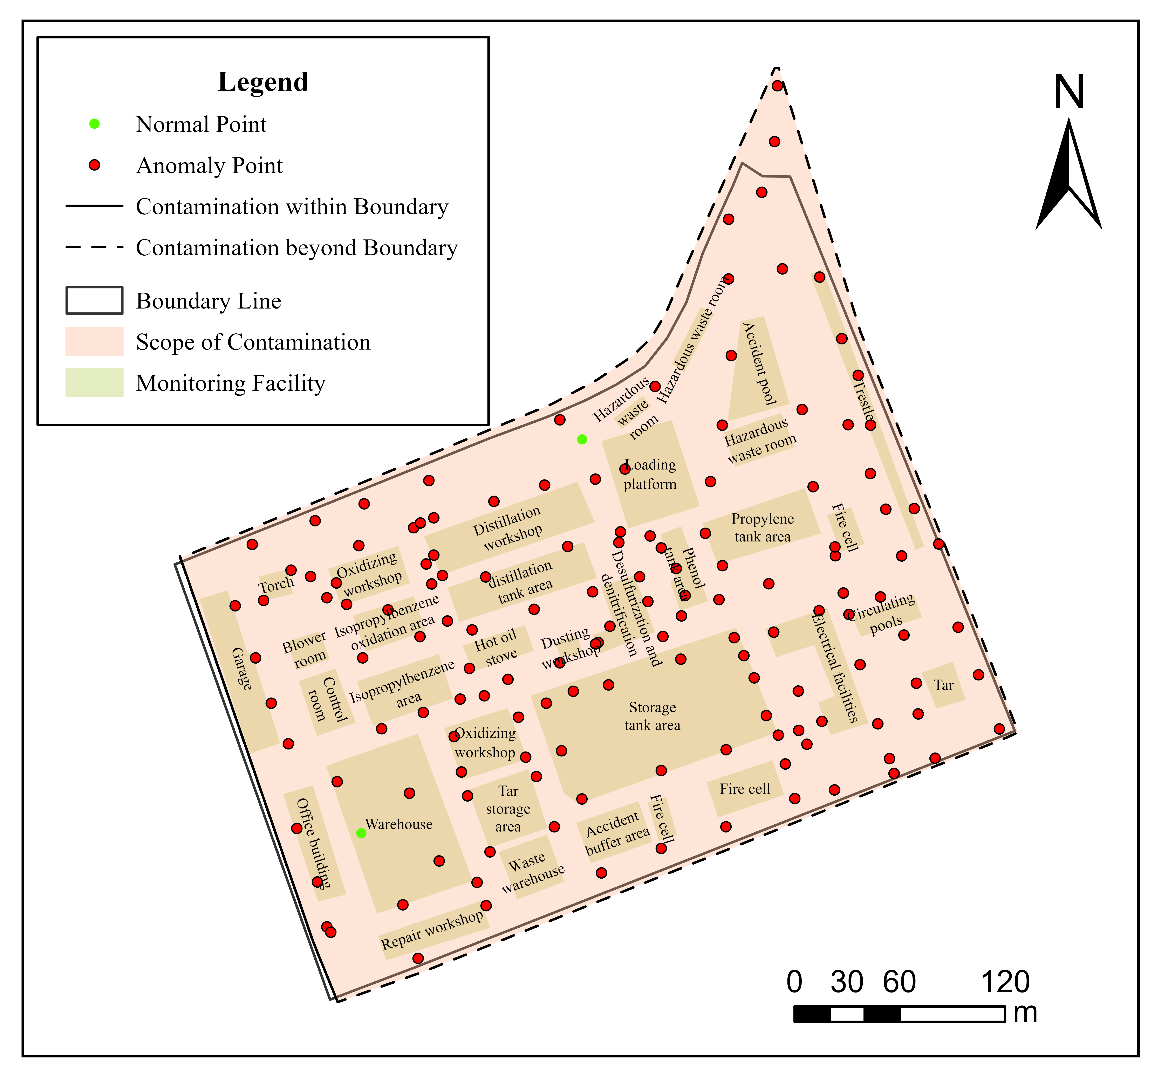
Figure 4: Contamination Scope
Legend: Red = Contamination Scope; White = Clean Soil

7. Risk Assessment
The results of the risk assessment of the actual park are not disclosed and the actual report can be referenced below.

7.1 Human Health Risks
The risk assessment follows the EPA RBCA Tier 1 methodology, integrating exposure pathways and receptor sensitivity.

7.1.1 Exposure Pathways
- Inhalation of soil gas (vapor intrusion into residential buildings).
- Dermal contact with contaminated soil.
- Ingestion of contaminated groundwater.

7.1.2 Receptor Analysis
The primary receptors include nearby residents living within 500 meters east of the site and potential future industrial workers on-site.

7.1.3 Risk Calculation
Table 4: Risk Assessment Summary
Contaminant | Carcinogenic Risk | Non-Carcinogenic Risk (HQ) | Exceeds Threshold?
Benzene | 1.2×10⁻⁴ | 0.8 | Yes
TPH (C6-C40) | N/A | 1.5 | Yes
Toluene | N/A | 0.6 | No
Threshold: Carcinogenic Risk >1×10⁻⁶ or HQ >1.0.

7.2 Ecological Risks
Ecological risks were assessed using the EU Soil Screening Values (SSVs) and EPA ECO-SSL guidelines.

7.2.1 Soil Toxicity
- TPH >10,000 mg/kg in Area A inhibits microbial diversity.
- Reduced earthworm survival rate observed in laboratory toxicity tests.

7.2.2 Surface Water Impact
The plume discharge into the nearby creek may affect benthic organisms. Predicted TPH concentrations exceed EPA aquatic toxicity thresholds.

7.3 Risk Summary
The risk assessment concludes that:
- Benzene and TPH pose unacceptable carcinogenic and non-carcinogenic risks to nearby residents.
- Groundwater contamination threatens drinking water supplies and aquatic ecosystems.
- Immediate mitigation measures are required, including vapor intrusion controls and source zone remediation.

8. Conclusions and Recommendations
The actual conclusions and recommendations of the report are not disclosed, and the actual report can be referenced below.
The NIS successfully identified the contamination source zone (Area A) with active volatilization and biodegradation processes.
Recommendations:
- Phase III Investigation: Install monitoring wells in Area A for contamination thickness quantification.Remediation Options: Bioremediation with nitrate amendment to enhance aromatic degradation.Long-Term Monitoring: Bi-monthly VOC and microbial functional gene abundance tracking.

